**Experiment No. 3**

**Title:**

Working in Cloud9 to demonstrate different language.

**Objective:**

To learn Platform as service (PaaS) using Free trial of Cloud9 in AWS, because firstly it was an independently platform now it is integrated with AWS.

**Tools used:**

Internet, AWS, EC2, Cloud9

**Prerequisite:**

Understanding of Platform as service in Service model of cloud computing

**Theory:**

AWS Cloud9 is an integrated development environment, or *IDE*.

The AWS Cloud9 IDE offers a rich code-editing experience with support for several programming languages and runtime debuggers, and a built-in terminal. It contains a collection of tools that you use to code, build, run, test, and debug software, and helps you release software to the cloud.

You access the AWS Cloud9 IDE through a web browser. You can configure the IDE to your preferences. You can switch color themes, bind shortcut keys, enable programming language-specific syntax coloring and code formatting, and more.

An *AWS Cloud9 environment* is a place where you store your project's files and where you run the tools to develop your applications.

Using the AWS Cloud9 IDE, you can:

* Store your project's files locally on the instance or server.
* Clone a remote code repository—such as a repo in AWS Code Commit—into your environment.
* Work with a combination of local and cloned files in the environment.

**Steps to setting up the cloud9**

**Step 1. Sign in to the Console**

[**https://aws.amazon.com/console/**](https://aws.amazon.com/console/)

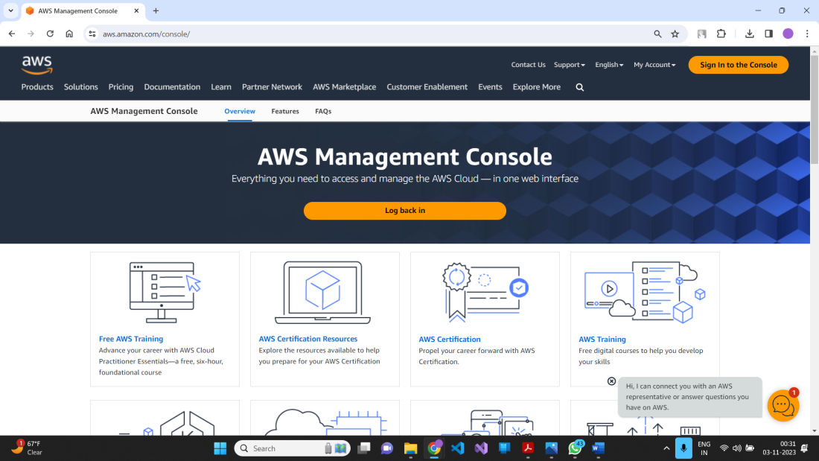

**Step 2. Create EC2 instance and Launch it**

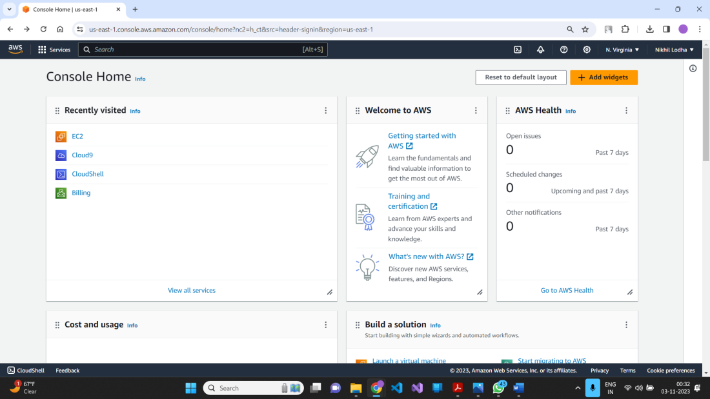

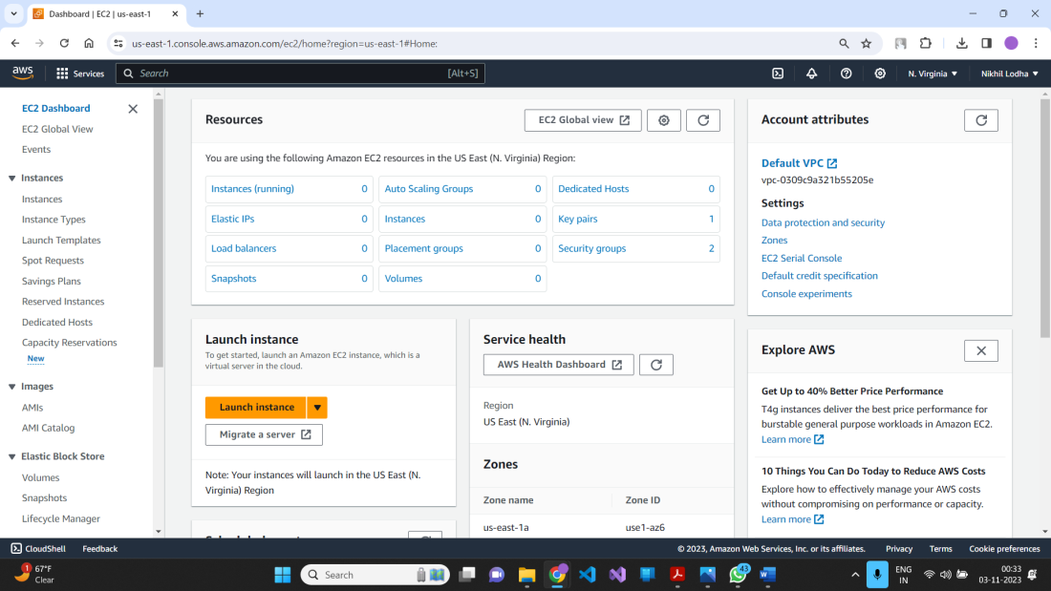

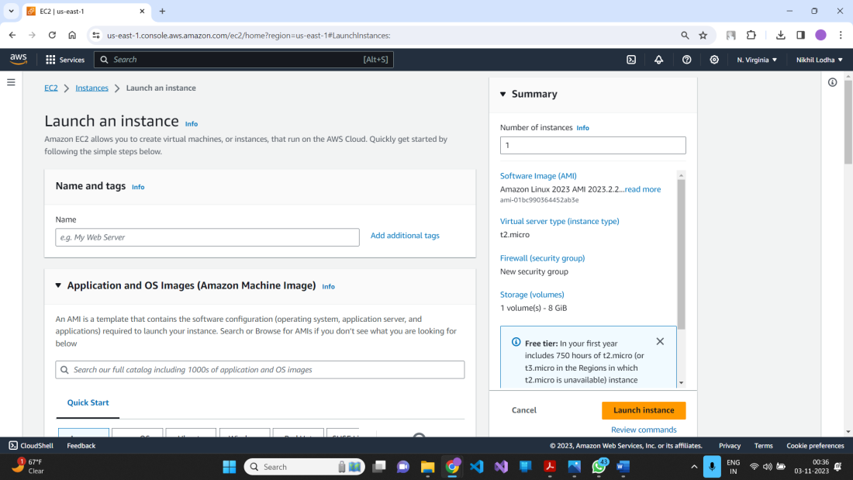

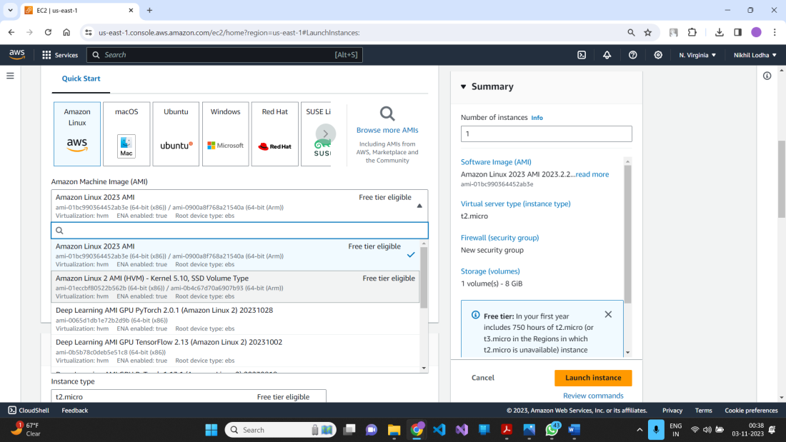

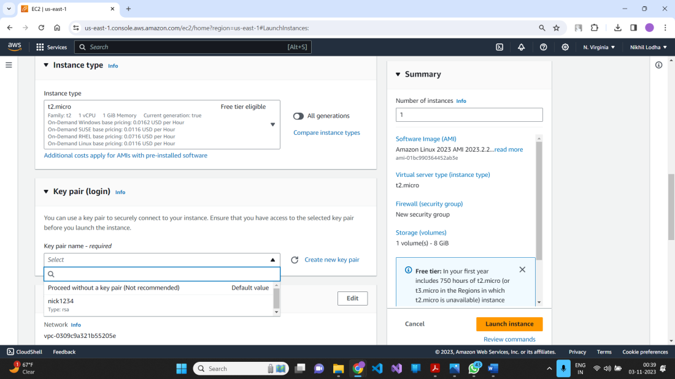

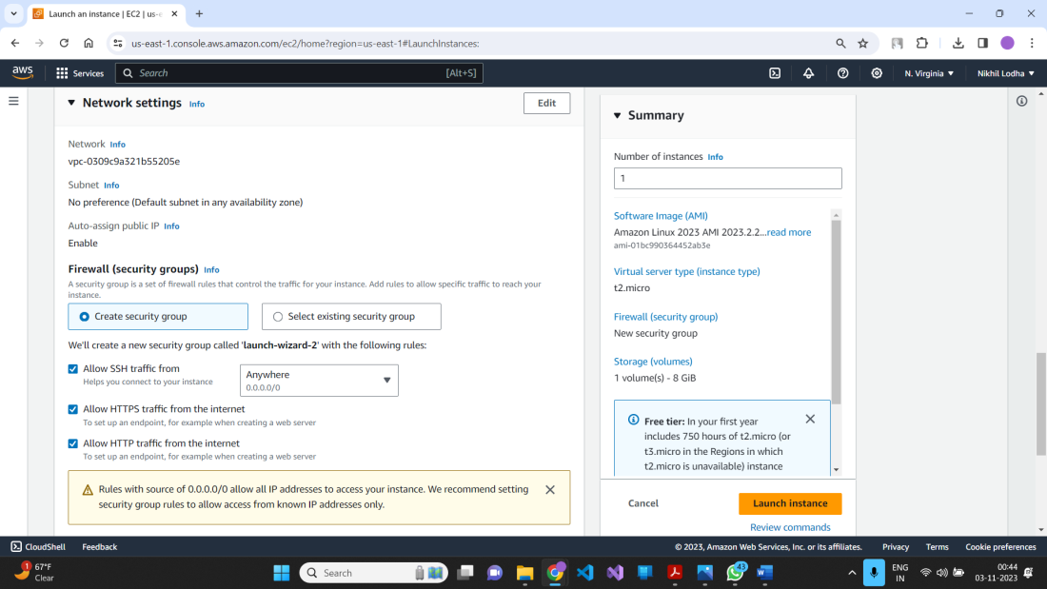

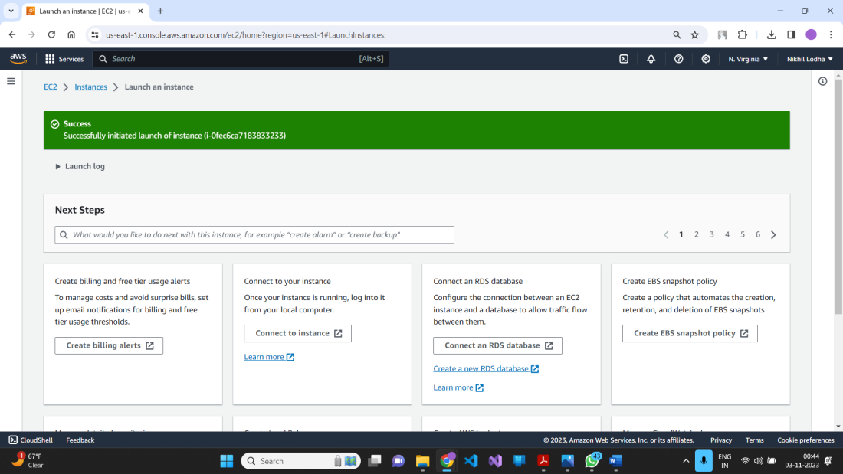

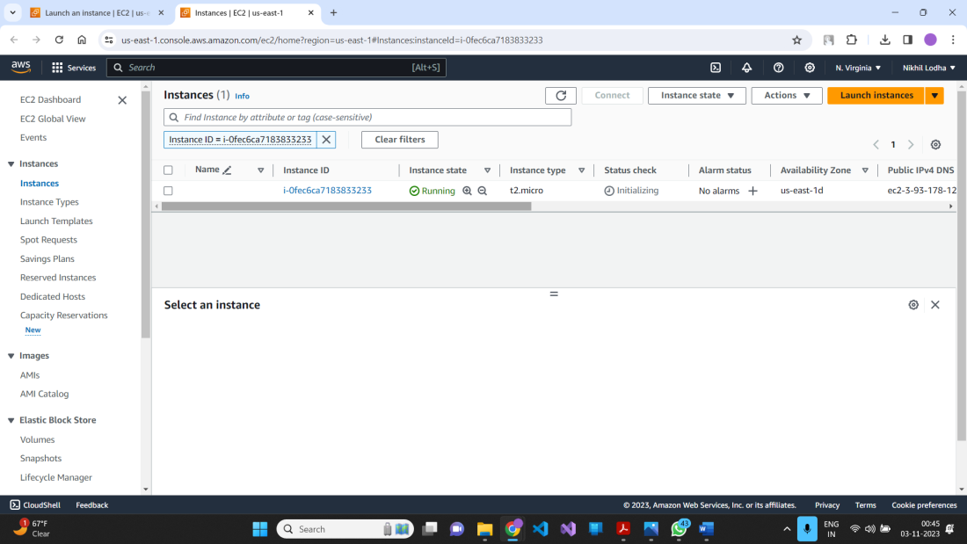

**Step 3 – Now we create instance and launch it, Now its time for Cloud9’s setup**

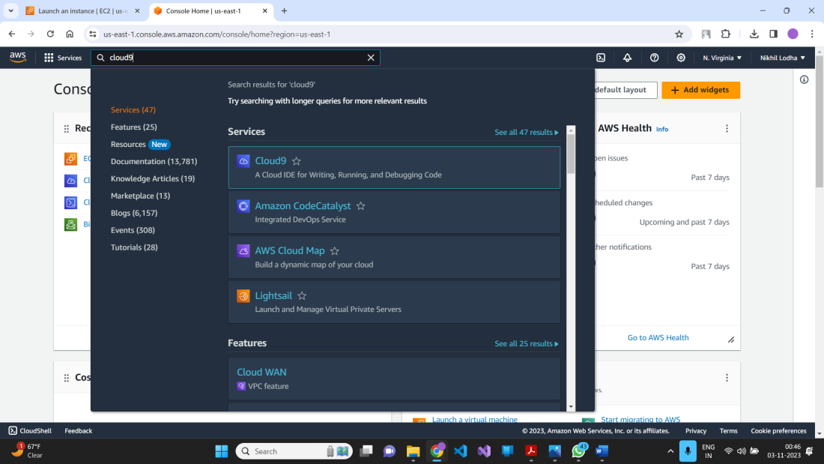

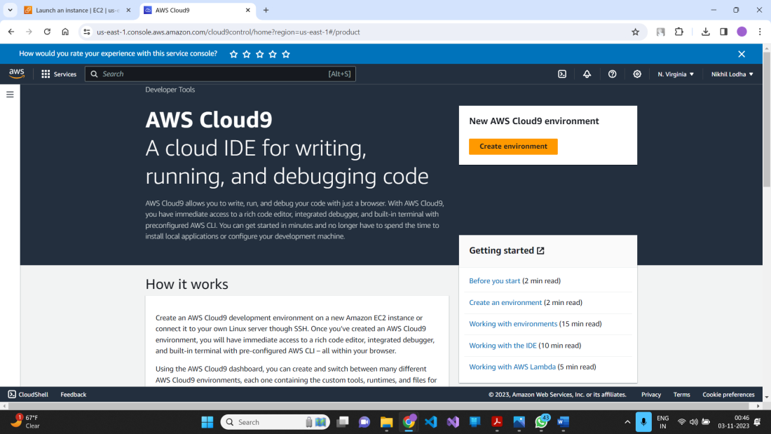

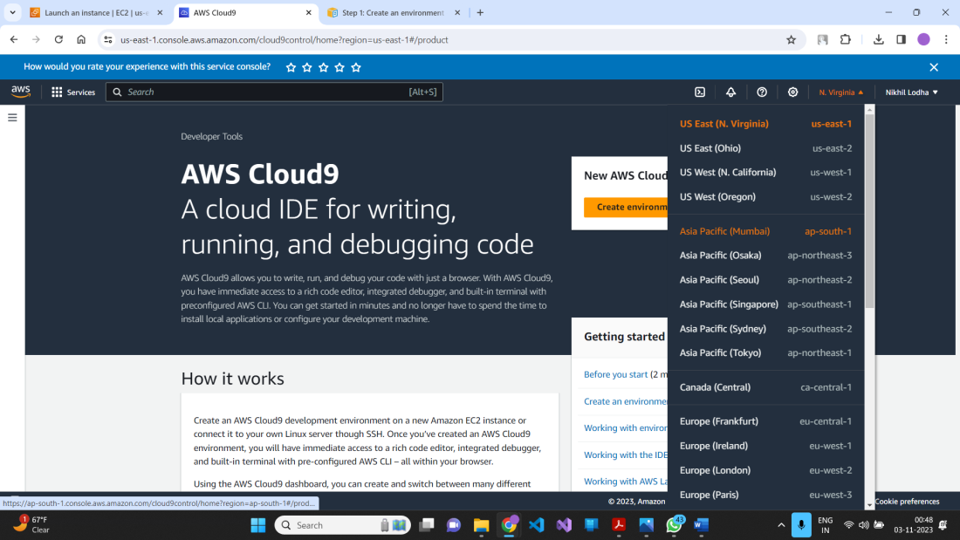

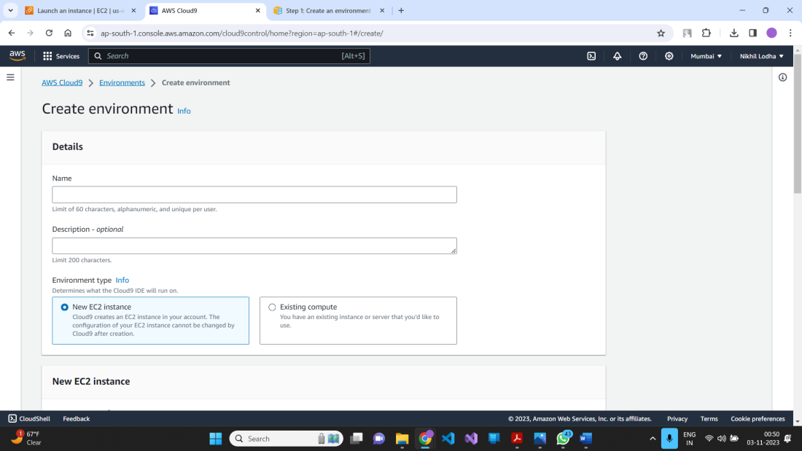

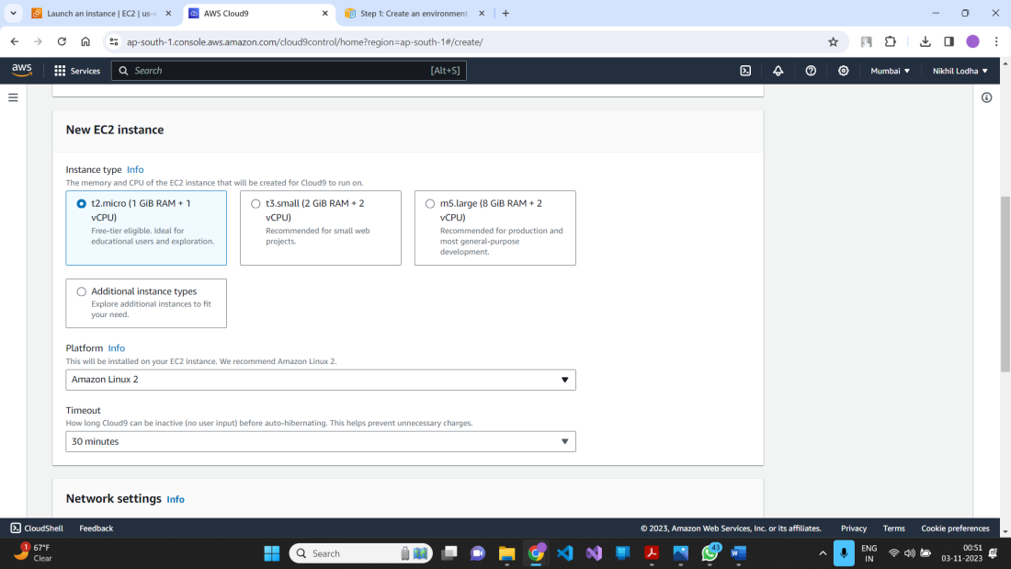

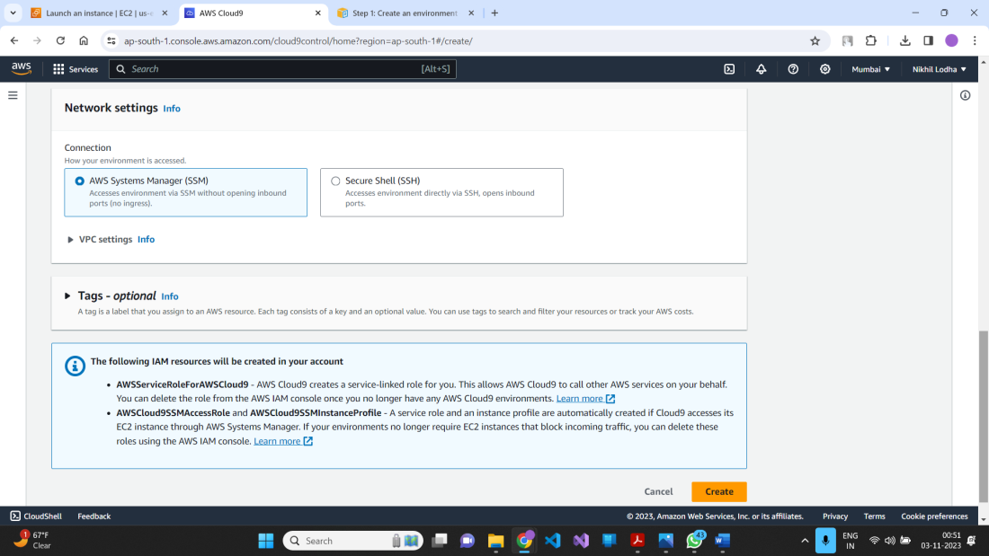

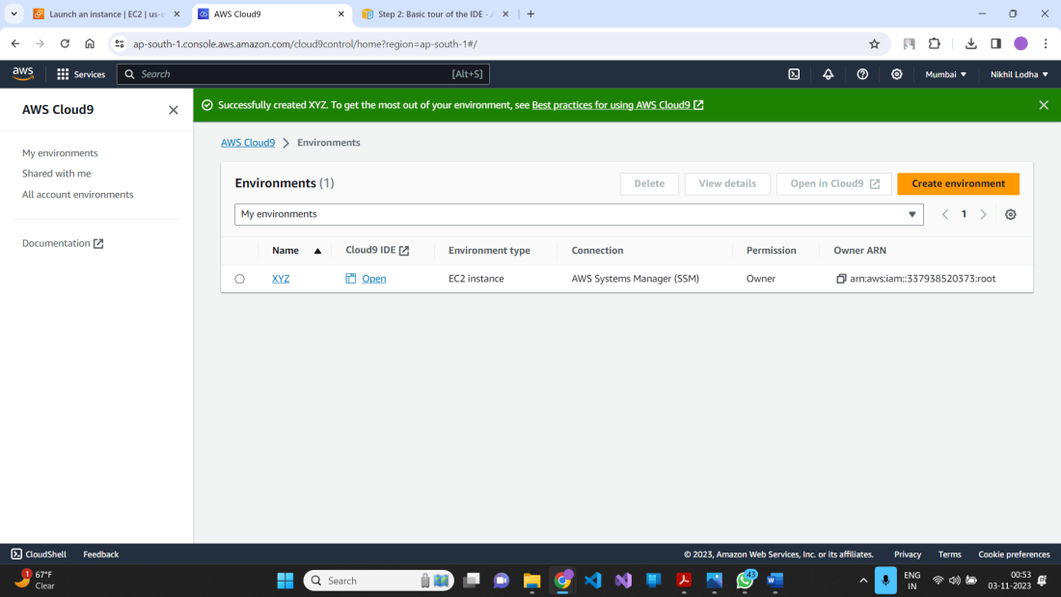

**Step 4 – After creating the cloud9 environment now we can start code in the environment**

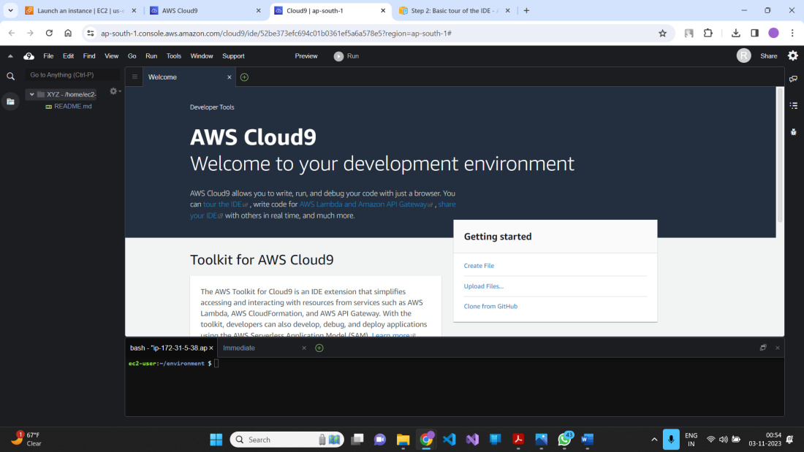

**Step 5. – Successfully Account is created**

npm install readline-sync

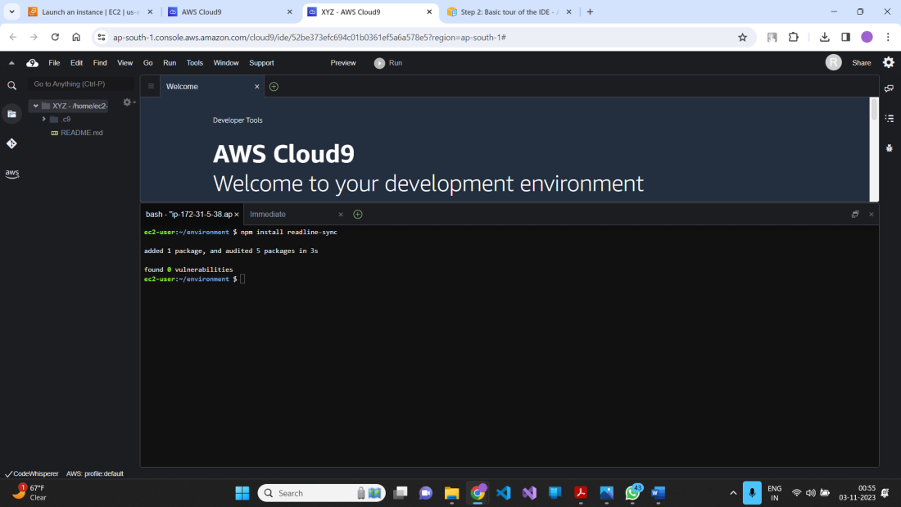

**Step 6. – Write the code in editor**

**Javacript code: var readline = require('readline-sync');**

var i = 10;

var input;

console.log("Hello Cloud9!");

console.log("i is " + i);

do {

input = readline.question("Enter a number (or 'q' to quit): ");

if (input === 'q') {

console.log('OK, exiting.')

}

else{

i += Number(input);

console.log("i is now " + i);

}

} while (input != 'q');

console.log("Goodbye!");

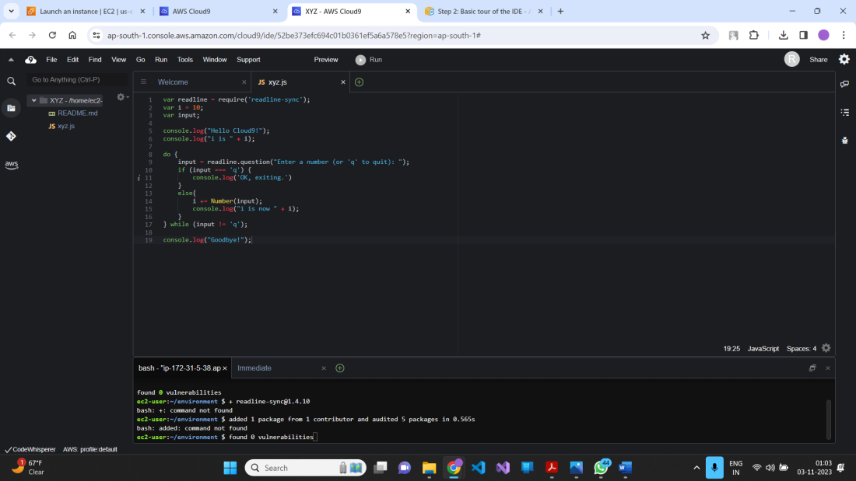

**Step 6. – Save the file and Run the code**

1. **Click on Run**
2. **Run Configuration**
3. **New Configuration**

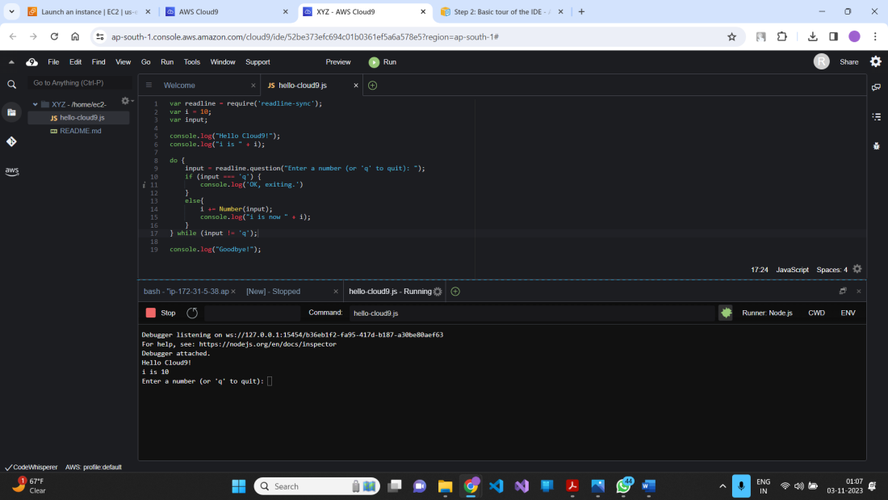

**In cloud9 you can write code in any languages like C++, C, python and many more.**